Facilities Manager
May 2023

- Welcome and information on how to apply
- Job Description & Person Specification
- Application Form
- Equal Opportunities Monitoring Form
- The Theatre Royal in Brief
- How to find the Theatre Royal

[

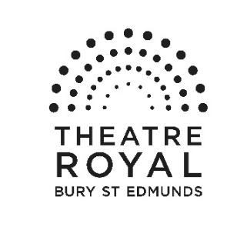

Vacancies at Theatre Royal Bury St Edmunds

Thank you for your interest in joining the team at Theatre Royal. Please find enclosed a job description for the post of Facilities Manager and some information about Theatre Royal which I hope will encourage you to apply to join us. Further information about the Theatre can be found on our website: www.theatreroyal.org.

If you would like to be considered for this post, please complete and return the application form and accompanying paperwork by midday on 9 June 2023

Interviews will take place on Monday 19 June 2023

Applications will be accepted by email to jobs@theatreroyal.org or by post.

Please mark your application Confidential - Recruitment

Post to: Sharron Stowe, Theatre Royal, Westgate Street,
Bury St Edmunds, Suffolk, IP33 1QR
Please notify via email that you have posted the application

Good luck and thank you for your interest in working at Theatre Royal.

Yours Sincerely

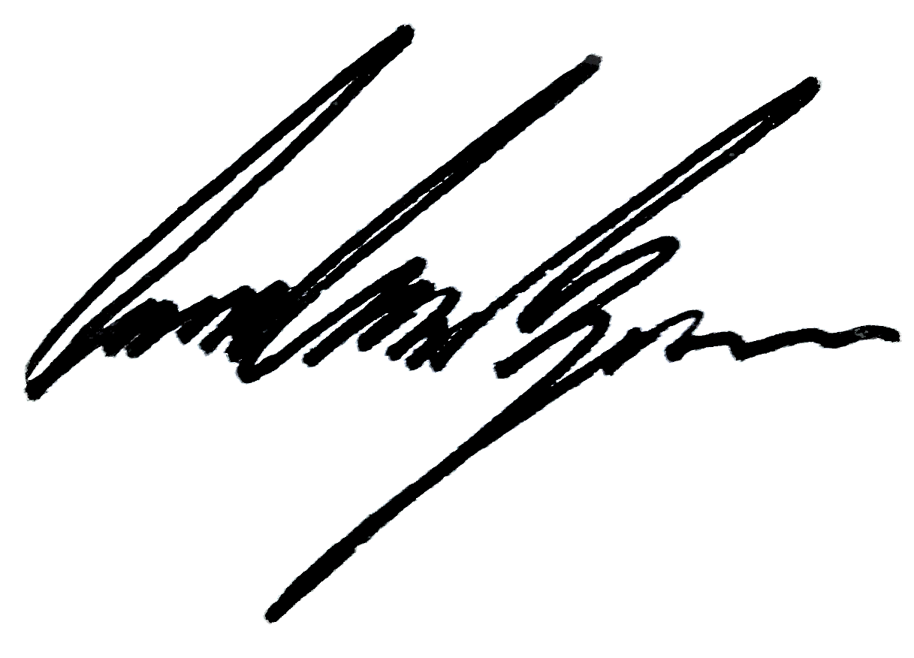

Owen Calvert Lyons
Artistic Director

Facilities Manager

Job Description

Purpose of post

This is a crucial role ensuring the smooth operation of this country’s only working example of a playhouse dating from the Regency period. The postholder will be responsible for coordinating the maintenance schedule around a busy programme of events whilst balancing the operational requirements of Health and Safety. Forging and maintaining business relationships with external contractors and the National Trust, covering the requirements of a Grade 1 heritage building.
The ideal candidate is a practical, people’s person with a can-do attitude.

Department: Finance & Central Services
Responsible to: Head of Finance & Central Services

Areas of Responsibility

- To work with National Trust to ensure premises are managed and maintained whilst satisfying operational requirements.
- To liaise with Greene King ensuring Access and premises are maintained in accordance to the lease.
- To lead the Health & Safety Group reviewing and revising Procedures. Disseminate and train where applicable and ensure procedures are adhered to.
- To complete and create a rigorous regular testing and risk assessment regime.
- To plan all maintenance requirements, scheduling a rolling maintenance plan in line with an annual budget.
- Identify and manage all contractors in relation to building maintenance and security.
- To be part of the operations meetings to ensure the smooth running of the company’s operations within the Theatre Royal’s premises and off site.
- To manage the cleaning contractors to ensure the building is well maintained and cleaning standards are high.
- To ensure all Theatre Royal’s policies are implemented including Health & Safety, Access, Environment and Risk Management.
- To ensure that the venue is locked and alarmed at the end of its use each day, and opened up at the start of each day.
- To be a designated key holder and coordinate the security of the Organisations Keys.
- To Manage the Organisations Storage facility.
- To monitor the environmental impact of the organisation and work with the Head of operations to set targets to reduce our environmental impact.
- Implement the Theatre Green Book
- To undertake any other reasonable duties as requested by Management.

The duties must at all times be carried out with due regard to all Theatre Royal Policies, which are detailed in the Company Handbook.

Person Specification

Essential skills, knowledge and qualities:

• Driving licence
- All round practical Maintenance skills
- Comprehensive knowledge of tools and how they work
- Working knowledge of domestic electrics and plumbing
- Ability to problem solve
- Resourcefulness
- Organisation skills
- Ability to think on your feet
- Flexibility, Adaptability and reactive
- People Person
- Willingness to undertake any appropriate training required

Desirable skills, knowledge and qualities:

• Legionella control of a responsible person City & Guilds
• Experience with Heating & Cooling systems & BMS (Building Management System)
- 1st Aid certificate
- Knowledge of Health & Safety rules

Terms & Conditions

Contract: This is a part-time post (30 hours), part of the core staff team and subject to a three month notice period

Salary: £24,284 per annum (pro-rata), payable monthly in arrears.

Hours of work: 30-hour week over 5 days and work flexibly to include day-time and evening shifts.

Place of work: Theatre Royal.

Annual Leave: 22 days plus Bank and other Public Holidays (pro rata). Additionally, you will be entitled to one additional day’s holiday per annum for every full year (1 April to 31 March) of service with the Company, up to a maximum of five additional days.
Allowances: Travel/mileage expenses whilst on Theatre Royal business.

Staff members receive an allocation of complimentary tickets for some performances at Theatre Royal for personal use only.

Pensions: We offer a workplace pension in line with statutory requirements.

Other information: There is a comprehensive staff handbook and induction plan with detailed information on policies, practices and working arrangements offered to all staff.

This post is subject to a probationary period of three months.

Theatre Royal operates an Equality Policy and the post holder is required to carry out his/her duties in accordance with this.

Please read the documents which accompany this form before completing your application.

Once completed, please return the form to jobs@theatreroyal.org or via post to arrive by

12 noon on 9 June 2023

Position Applied for (include no of hours)
Where you saw advert

1 Personal Details

Surname
Forename(s)
Address | Postcode
Telephone (day)
Telephone (evening)
Email address
National Insurance Nº

2. Why are you applying for this post?

3. What can you offer us?
Please include details of any relevant skills, experience and knowledge (there are later sections for information about training and education)

4 Current or most recent employment/experience of work

Name and address of organisation | Postcode
Position held
Salary (if applicable)
Date appointed
Date left appointment and why (if applicable)

Outline briefly your duties and responsibilities

5 Previous appointments/experience of work

Name and address of organisation | Position held and dates | Main duties and responsibilities | Reason for leaving
6 Training and education
Please include details of exams passed, courses attended and qualifications obtained

7 What else are you interested in?
for example, what are your leisure activities

8 Additional Information please delete where applicable

Do you need a permit to work in the United Kingdom? YES / NO

Do you have any condition or disability which may affect your ability to do the job, and/or require us to make reasonable adjustments? YES / NO

If Yes please give details including any adjustments that you may need to be made both in respect of the job and the interview

9 Travel
Some positions at the Theatre Royal require employees to drive, if this is applicable to the position you are applying for, please complete this section

Do you hold a current, clean driving licence? YES / NO
Do you have access to/have the use of a car? YES / NO

If the answer to either of these questions is No, please explain how you would meet the travel requirements of the post (where applicable)

10. Confidential Declaration of Criminal Record

Some positions at the Theatre Royal require employees to be responsible for or come into contact with young people aged under 18 and vulnerable adults. If this is applicable to the position you are applying for, you will be required to undertake an Enhanced DBS Check.

Please note that all posts which involve working with young people aged under 18 and vulnerable adults at the Theatre Royal are exempt from the Rehabilitation of Offenders Act 1974, which means that all convictions, cautions, reprimands and final warnings on your criminal record need to be disclosed.

11 References

Please supply the details of two persons (other than relatives) from whom references can be obtained. If you have had previous employment one of your referees should be your current or most recent employer.

Name  Address  email address  Daytime telephone number  Occupation  Employer/Personal Referee (delete as appropriate) | Name  Address  email address  Daytime telephone number  Occupation  Employer/Personal Referee (delete as appropriate)

Are you willing for references to be contacted prior to interview? YES / NO

12 Declaration

I confirm that the information I have given on this form is correct and complete to the best of my knowledge, and that misleading statements may be sufficient for cancelling any agreements made.

I understand that, if the position I am applying for is responsible for young people aged under 18 and vulnerable adults, I will be required to complete a Criminal Records Bureau enhanced disclosure if appointed.

Signed
Date

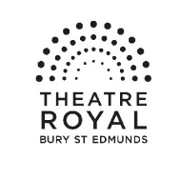

Equality and Diversity Monitoring Form

Theatre Royal Bury St Edmunds is committed to a policy of equality of opportunity in all aspects of its recruitment and employment. This includes not discriminating under the Equality Act 2010, and building an accurate picture of the make-up of the workforce in encouraging equality and diversity.

The organisation needs your help and co-operation to enable it to do this. There is no obligation for you to complete the form.

The information submitted will be treated in the strictest confidence.

Please return the completed form to Sharron Stowe

Role
Gender Man Woman Intersex Non-binary Prefer not to say
Are you married or in a civil partnership? Yes No Prefer not to say
Age 16-24 25-29 30-34 35-39 40-44 45-49 50-54 55-59 60-64 65+ Prefer not to say
What is your ethnicity?
Ethnic origin is not about nationality, place of birth or citizenship. It is about the group to which you perceive you belong. Please tick the appropriate box

White
English Welsh Scottish Northern Irish Irish
British Gypsy or Irish Traveller Prefer not to say
Any other white background, please write in:

Mixed/multiple ethnic groups
White and Black Caribbean White and Black African White and Asian Prefer not to say Any other mixed background, please write in:

Asian/Asian British
Indian Pakistani Bangladeshi Chinese Prefer not to say
Any other Asian background, please write in:

Black/ African/ Caribbean/ Black British
African Caribbean Prefer not to say
Any other Black/African/Caribbean background, please write in:

Other ethnic group
Arab Prefer not to say Any other ethnic group, please write in:

Do you consider yourself to have a disability or health condition?
Yes No Prefer not to say

What is the effect or impact of your disability or health condition on your ability to give your best at work? Please write in here:

The information in this form is for monitoring purposes only. If you believe you need a ‘reasonable adjustment’, then please discuss this with your manager, or the manager running the recruitment process if you are a job applicant.
What is your sexual orientation?
Heterosexual Gay Lesbian Bisexual
Prefer not to say If you prefer to use your own term, please specify here ……………………………………………….….

What is your religion or belief?
No religion or belief Buddhist Christian Hindu Jewish
Muslim Sikh Prefer not to say If other religion or belief, please write in:
What is your current working pattern?
Full-time Part-time Prefer not to say

What is your flexible working arrangement?
None Flexi-time Staggered hours Term-time hours
Annualised hours Job-share Flexible shifts Compressed hours
Homeworking Prefer not to say

Do you have caring responsibilities? If yes, please tick all that apply
None Primary carer of a child/children (under 18)
Primary carer of disabled child/children
Primary carer of disabled adult (18 and over) Primary carer of older person
Secondary carer (another person carries out the main caring role)
Prefer not to say

About Us
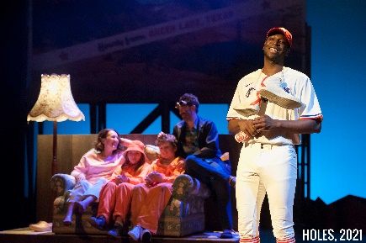
Theatre Royal Bury St Edmunds works to transform the lives of people in its local community through the power of the performing arts. We believe everyone, at all stages of their lives, regardless of background or personal circumstance, should have equal opportunity to engage in extraordinary cultural experiences.
Theatre Royal is a vibrant 200-year-old theatre located in the beautiful Suffolk town of Bury St Edmunds. First built in 1819, it was restored to its original regency design in 2007 and as a Grade 1 listed building, is the only theatre in the National Trust portfolio and considered to be one of the cultural sector’s ‘crown jewels’. As the last working Regency playhouse in the country, it offers visitors a unique and unforgettable theatrical experience.
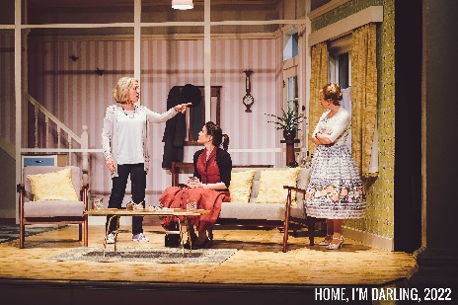
A major cultural and social asset and a key part of West Suffolk’s culture, heritage and tourism offer, we serve a population of 370,000. We are the only theatre in West Suffolk that both receives and produces high quality theatre, reaching 80,000 audience members each year. We pride ourselves on the quality and innovation of our in-house productions, with recent successes including: A Christmas Carol, Home, I’m Darling, and The Secret Garden. Our eclectic programme is carefully curated to ensure we have something for everyone, whether it’s cutting-edge contemporary theatre, traditional drama, dance, comedy, music spanning genres from classical to pop, or award-winning productions for children and young people. Over 20,000 people attend our renowned annual family pantomime each year.
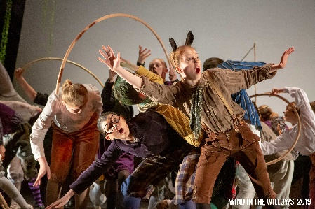
We pride ourselves on putting our community at the heart of everything we do. Our performing arts programme is augmented by a wide reaching & diverse Creative Learning offer which engages targeted community groups through bespoke partnerships. Our ambition is to further embed the voice of our community within all aspects of our offer, ensuring that our cultural & education programmes are designed with, by and for the people of West Suffolk.

The theatre employs a paid staff of 25 alongside a wider team of casual staff and supported by a dedicated team of approximately 140 volunteers. It is overseen by a highly skilled non-executive board of trustees. There is a Patron's Scheme and a thriving Friends scheme numbering over 600 members. The theatre receives core funding from West Suffolk Council and Suffolk County Council and also enjoys strong support from the local business community.

Vision + Mission
Our vision is to bring the Theatre Royal into the heart of our residents. Our mission is to shape, produce and showcase high quality, diverse theatre and participation activities that reach all corners of our community.

Values

Expansive: we work beyond the walls of our 19th century building
Inclusive: we are open to all, both on and off stage
Transformative: we transform the lives of our community through work that is unexpected, high quality, entertaining and thought provoking
Collaborative: we work in partnership, learn from others and share the knowledge and expertise we have
Resilient: we are steadfast in our approach to strong governance, operational leadership and financial acumen

How to get to Theatre Royal

On arrival, please report to the Box Office at the Theatre.
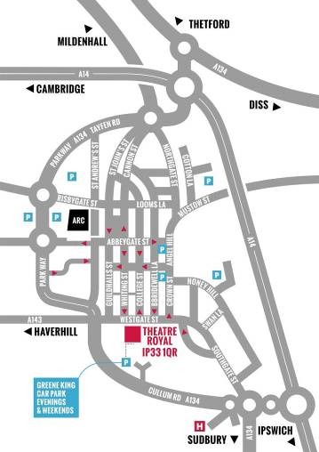
By Road
Bury St Edmunds is just off the A14, east of Cambridge and west of Ipswich. From the Midlands or the East Coast, follow the A14. From London, take the M25 and M11/A11 then A14 heading east (signposted Newmarket / Ipswich / Felixstowe). Approaching from the west, take the third exit for Bury St Edmunds and turn right at the big roundabout towards the town centre. Go right at the next roundabout then right at the third roundabout onto Southgate Street. Follow the road and you will join the one way system; the Theatre is on your left opposite the Greene King Beer Cafe.

Car Parking
The Theatre has no parking of its own. There is very limited parking close to the Theatre. We normally recommend the Angel Hill or Premier Inn car parks as the closest viable options. There are a number of unlimited street parking places on Westgate Street after 6.00 pm.

By Bus
The Bus Station is on St Andrew’s Street North, 10 minutes’ walk from the Theatre. In addition to local services, it is serviced by National Express coach connections from all over the country. Enquiries/Reservations: 01284 702020

By Train
Bury St Edmunds Railway Station is on Station Hill and is 20 minutes’ walk from the Theatre, connecting to Cambridge, Ipswich and the London to Norwich line.
Enquiries/Reservations: 08457 484950

Local Taxis
5 Star Cars 01284 703131 / 01284 704078
A1 Cars 01284 766777
Premier Cars 01284 704004
Star Cars 01284 760707
United Cars 01284 762288 / 01284 764074

