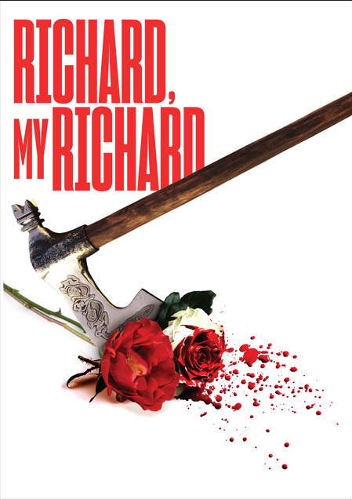

EASY READ AND VISUAL STORY

Richard,My Richard
Written by Philippa Gregory

Co-produced by THEATRE ROYAL BURY ST EDMUNDS and SHAKESPEARE NORTH PLAYHOUSE
In association with DANIEL SCHUMANN

This is a full synopsis of the show with matching photographs and details for anyone who may benefit from knowing the story and details ahead of time.

Please note that this guide will contain spoilers.

For more information regarding accessing the building, please visit https://theatreroyal.org/your-visit/access/

Content Warning

At points during the production, there will be:
Loud sudden noises or music
Flashing lights
Stage haze
Scenes depicting violence
Characters expressing anger, fear, sadness, threat
Characters moving through the audience

The scenes in which these happen will be clearly identified within this pack.

We do have a small stock of ear-defenders available for those who would like to use them.

Please also note:
Throughout the show, several members of the cast will be playing more than one role.
The roles of each of our company are labelled clearly next to their name within this pack.

Performance Times
This show is 2 hours and 20 minutes long including the interval.
Act One: 1 Hour
Act Two: 1 Hour

Cast

Tom Kanji – History
Kyle Rowe – Richard
Jennifer Matter – Queen
Laura Smithers – Margaret
Matt Concannon – Edward and Thomas Stanley
Tori Burgess – Anne and Henry
Mary Savage – Elizabeth and the Prince
Tyler Dobbs – George and Buckingham

Production Team

Writer – Philippa Gregory
Director – Katie Posner
Assistant Director – Joey Colasante
Producers – Zoe Fox and Siobhan Noble
Assistant Producer - Bridget Mulroy
Designer – Richard Kent
Movement Director – Annie-Lunnette Deakin-Foster
Lighting Designer – Philip Gladwell
Lighting Programmer - Luca Panetta
Sound Designer – Beth Duke
Sound Associate – Rose Farbrother
Costume Supervisor – Alice Roberts
Dramaturg – Sarah Dickenson
Production Manager – Andy Stubbs
Company Stage Manager – Jon Calvert
Deputy Stage Manager – Becky Brown
Assistant Stage Manager – Tabitha Dodds

Photography – Tom Soper
Videography – Dan Cole Media

Characters

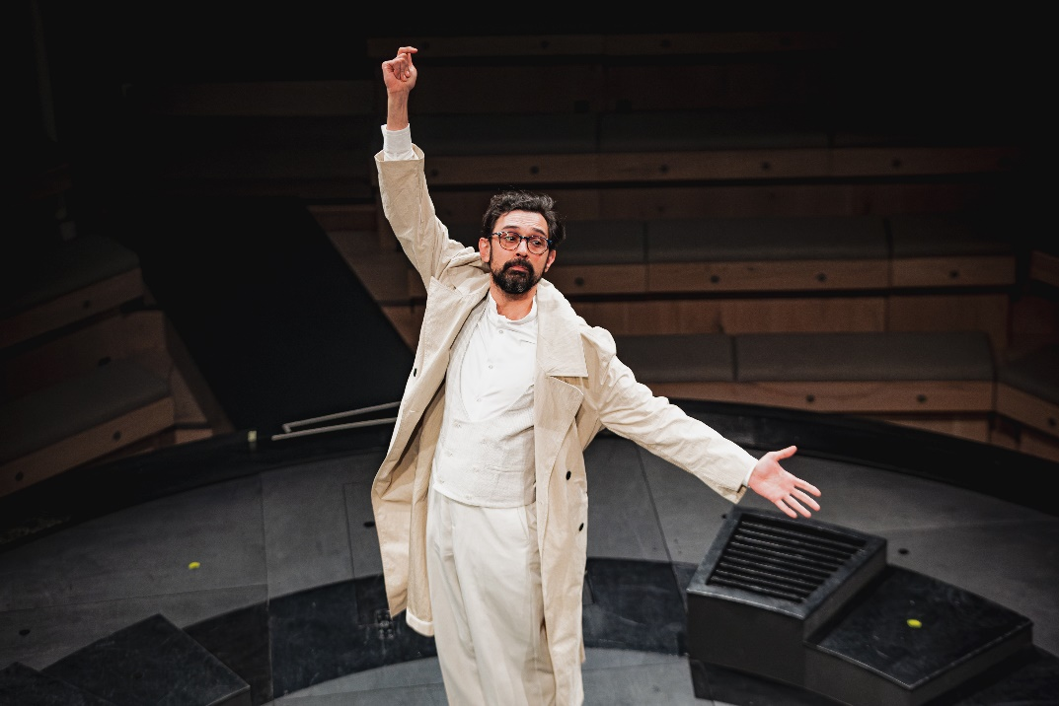

History
The man who knows everything.

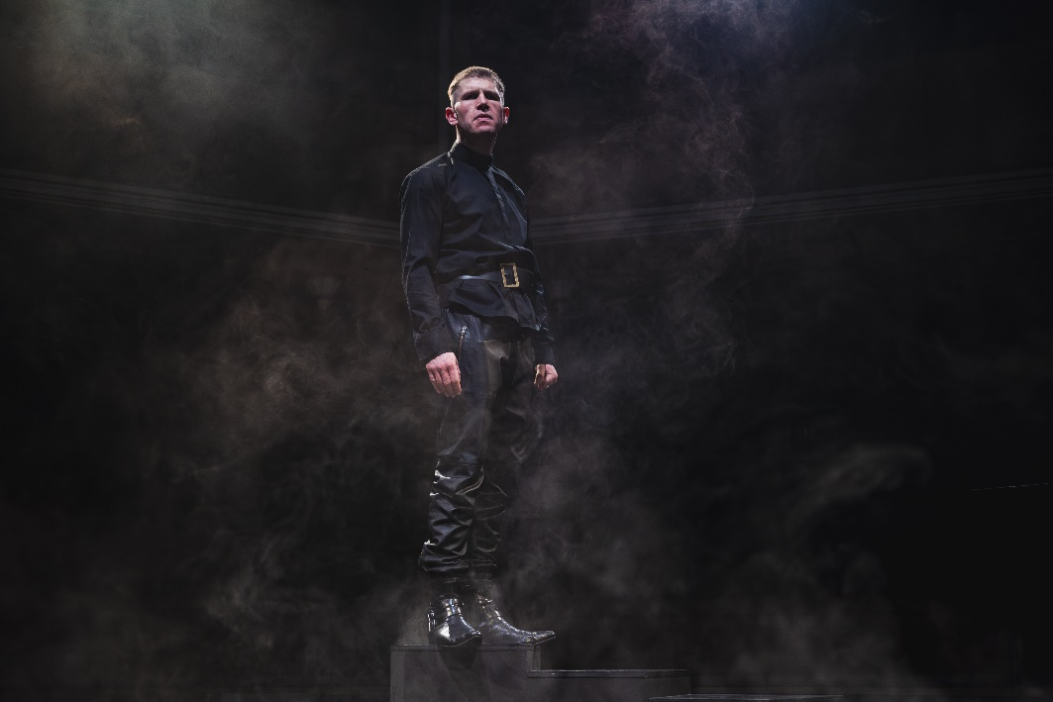

Richard
Battle hardened. He is young, handsome, and one of the gilded Plantaganet youth who thinks they are bound to win at everything.

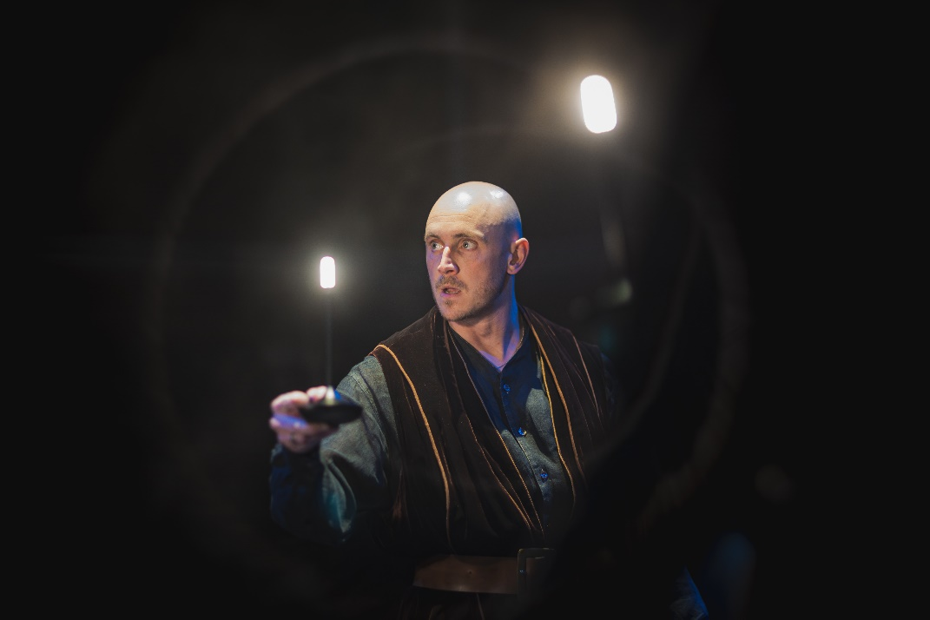

Edward
Brother to Richard. Tall and famously handsome. He’s hugely charming and determined and he and his wife Queen Elizabeth passionate and demonstrative.

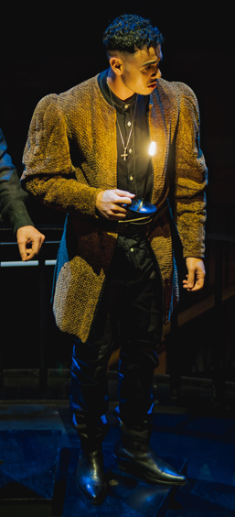

George
Brother to Richard. Handsome gentleman, married Isabel for the chance of winning the throne, is eaten up with ambition and hatred of Queen Elizabeth.

Anne
Tough and astute. Childhood sweetheart of Richard III, she seizes the chance of marrying him and getting away from the Lancaster side at the battle of Tewkesbury 1471 when she is 15.

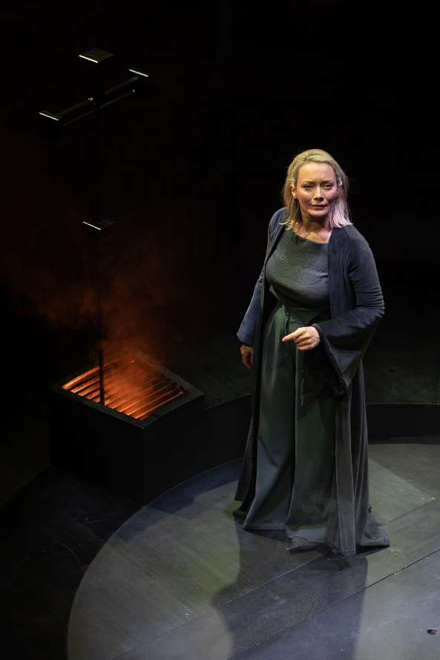
Queen Elizabeth
Formidable and famously beautiful, wife to Edward. An absolute enemy of Richard III. She is hugely ambitious and determined and unscrupulous but she has a redeeming and passionate love for her husband the man (as well as the king) and for her sons, and for her daughters.

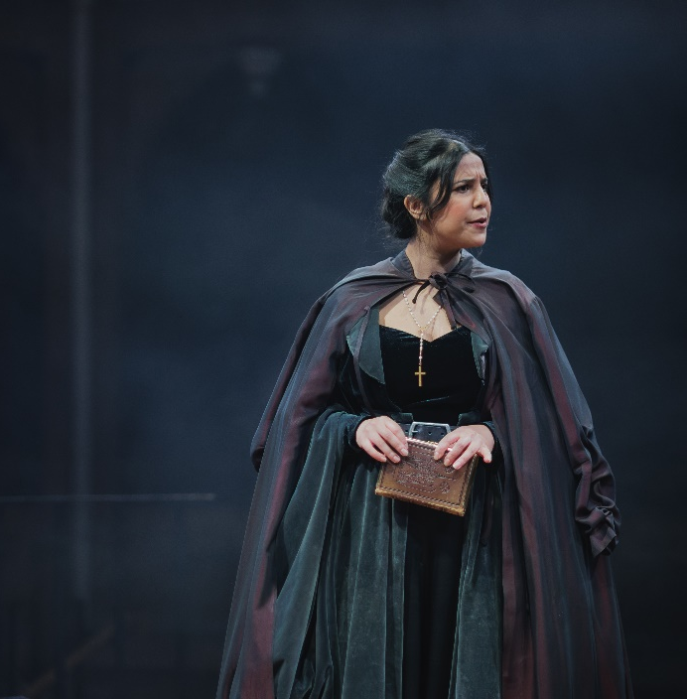
Margaret
Elizabeth’s rival, enemy, and equal, some-time friend. A devout Roman Catholic Margaret knows that God speaks to her personally and has called her to put her son Henry on the throne for the Lancaster side of the family. She has devoted her life (two subsequent marriages) to positioning herself so that she can put Henry on the throne.

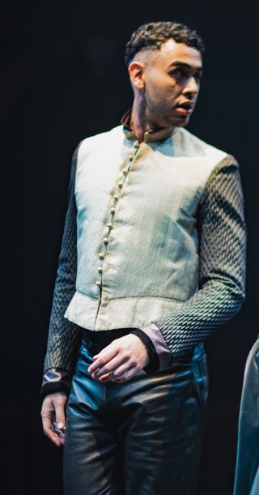
Buckingham (Henry Stafford)
A spiteful entitled teenager with sudden access to power. Hugely resentful, having been raised at court by Elizabeth Woodville who has profited from his guardianship and given him in marriage to her very much older sister. He is in a state of impotent fury until Margaret Beaufort shows him a way to be revenged on the Yorks and (he thinks) to take the throne from himself.

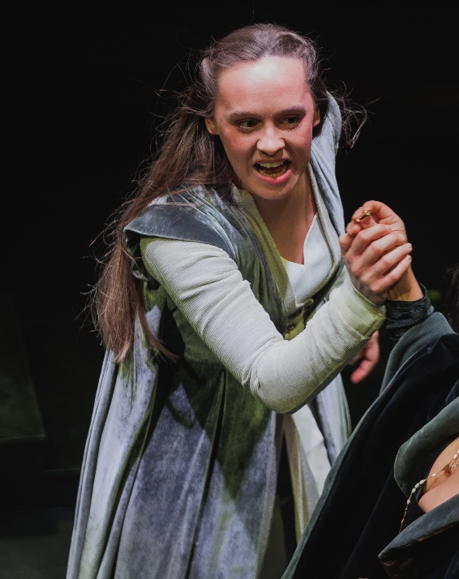
Elizabeth of York
Young and beautiful and she leaps into love with Richard as into a full life – after months in the darkness of sanctuary. She was raised as such an adored daughter and princess that her father failed to complete the arranged marriages which would have taken her away from England, so she is one of the few women in the play who have a strong sense of themselves as a valued woman.

Thomas And William Stanley
Brothers who manage a brilliant family tradition of joining opposite sides in any English battle so that the Stanleys are always on the winning side. They are so familiar and so close that they finish each other’s sentences and rarely need to speak at all. STANLEY is terrified that Richard has discovered the plot with Margaret and does – indeed – dive under the table. The Stanley brothers don’t care who wins at BOSWORTH but they want maximum profit, and it is better for them to save HENRY TUDOR than RICHARD.

Set

For this performance our auditorium has changed into a staging configuration called ‘In the Round’.
This means that the audience will be sat surrounding the stage.

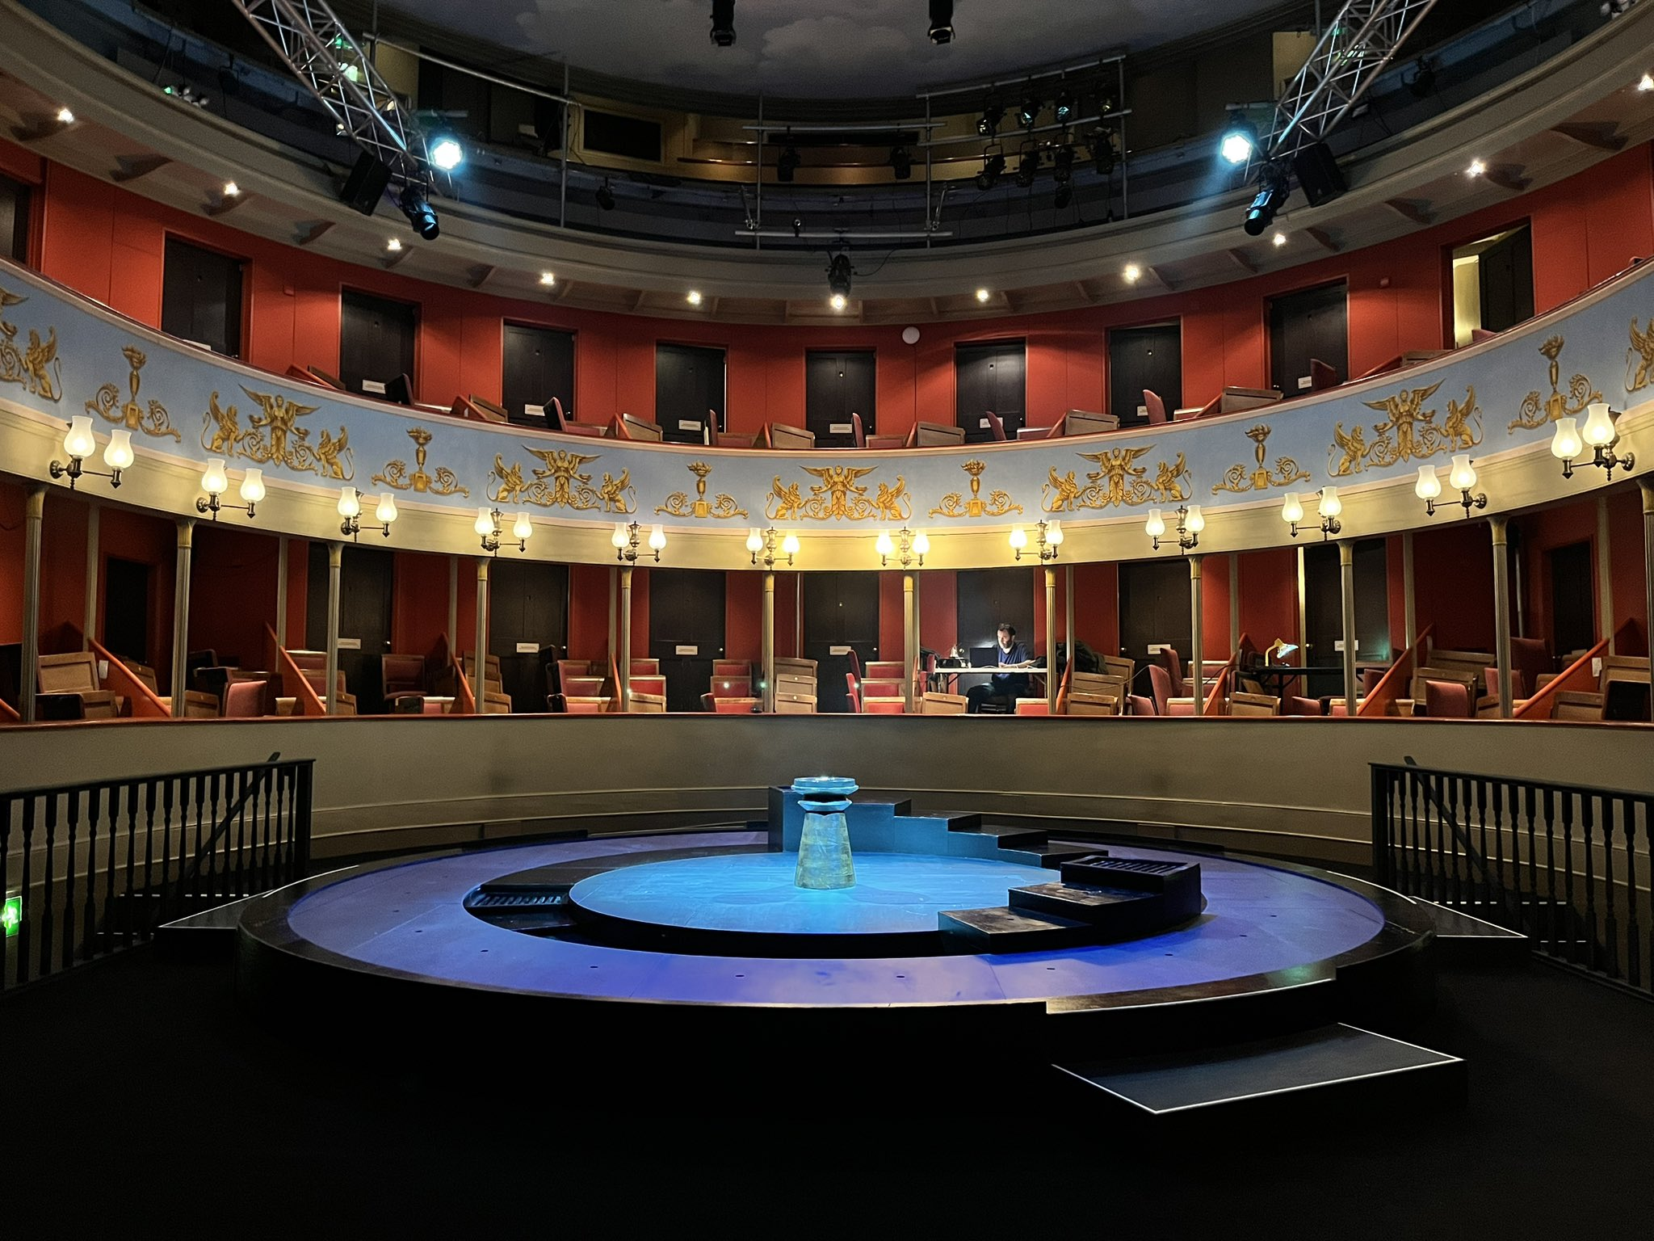

Please note: Within the show, actors will enter the auditorium in different manners to how they would usually.

Richard (Played by Kyle Rowe) will first appear from below the auditorium

History (Played by Tom Kanji) appears within the audience at certain moments in the play. These are commented on within the breakdown below.

Act One

History introduces himself to the audience as Richard emerges from his grave. Richard does not realise what has happened to him, thinking he is still King of England. History shows him the record of his life and death and explains what has happened since as well as Richard’s bad reputation. Richard defends himself and History promises to review the record of his life.
NOTE: loud sudden noises, music, flashing lights, characters moving through the audience throughout, characters expressing anger, stage haze / dry ice throughout.

Richard’s brothers (Edward and George) enter, followed by Anne, who is angry that Richard has killed her father. However, she soon suggests that they marry and they have a private wedding. Edward kills the king so he can become King himself. To help the audience understand, History explains how everyone is connected to each other and who has killed who to gain power.
NOTE: music, loud sudden noises

Edward’s wife is pleased to be Queen, but is upset that her father and brother have been killed and that Anne is connected with their murderer. A hooded messenger appears and George discovers that his wife, Anne’s sister, is dead. He fears that the Queen has cursed her and insults her, so King Edward locks him in a tower and sentences him to death. Hooded figures depict drowning him.
NOTE: music, sound effects, characters expressing anger, fear and threat, scene depicting violence.

Margaret explains how her son could have a claim to the throne. King Edward is dying and makes his last requests, including that his brother Richard become guardian of his son until he is old enough to be King. The Queen wants her son to be crowned against her husband’s will and her son argues with Richard for his right to be King. Richard swears to crown him eventually, but puts him in a tower in the palace with his brother. He explains to History that this was to keep them safe rather than imprison them.
NOTE: character moving through audience, music.

Anne is sick and claims the Queen has cursed her. Meanwhile, Elizabeth, the Queen’s daughter, says she will marry anyone to protect her brothers. She considers marrying Margaret’s son, Henry Tudor, even though she does not trust Margaret.
NOTE: characters expressing anger, fear and threat, music

Act Two

Richard gives a speech as King. Meanwhile, Margaret and Buckingham plot to kill the princes in the tower, thinking that Richard will be blamed. Richard defends himself to History, explaining that he had no motive to kill the princes as he was already King. He then tells the Queen that her sons have mysteriously vanished from the tower and she curses whoever took them. Buckingham is killed, then Margaret is arrested by her own husband under suspicion.
NOTE: characters moving through the audience throughout, loud noises, music, stage haze throughout.

Richard’s son dies, and Anne, who is sick, tells Richard that he should remarry when she dies to gain an heir. She suggests Elizabeth, who then dresses in Anne’s robes. When Anne dies, Elizabeth marries Richard. History reminds Richard of the Battle of Bosworth; which Richard cannot remember as he knows it by another name.
NOTE: music, loud noises.

Richard puts on armour ready to fight, saying he was not afraid. We hear the sounds of battle as it is represented on stage by Richard tearing at the flags on poles. He remembers his death, and asks about his burial. History promises to honour him and grants him rest in peace.
NOTE: loud noises, music, fight scene, characters expressing anger, fear, threat and sadness

